1. Go to the transaction SE24.
2. Enter the class name **CL_EXITHANDLER**. Click on Display.

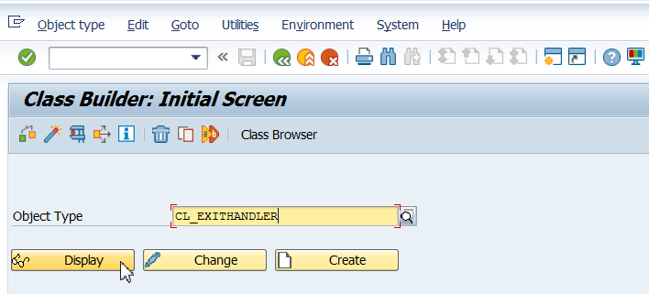

1. Double-click the method **GET_INSTANCE.**

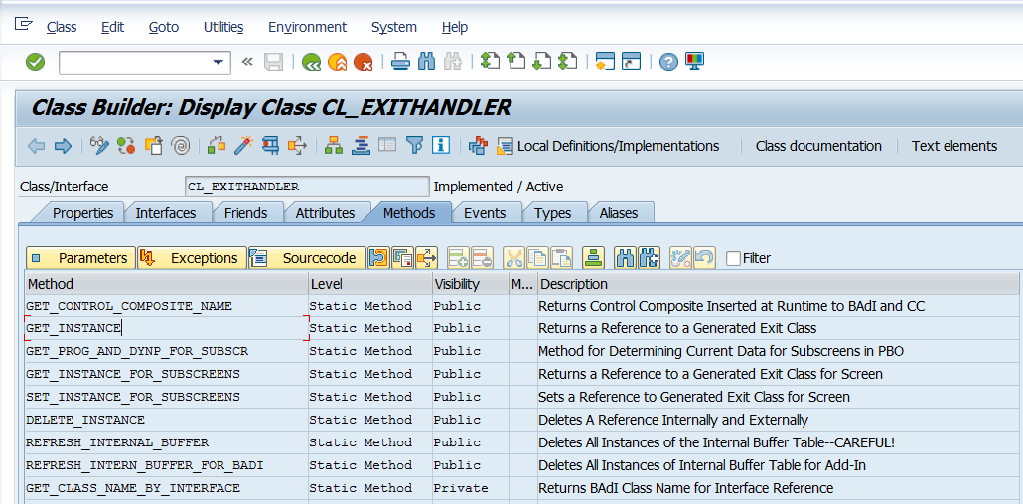

1. Set a break-point at command line CASE sy-subrc (line 25).

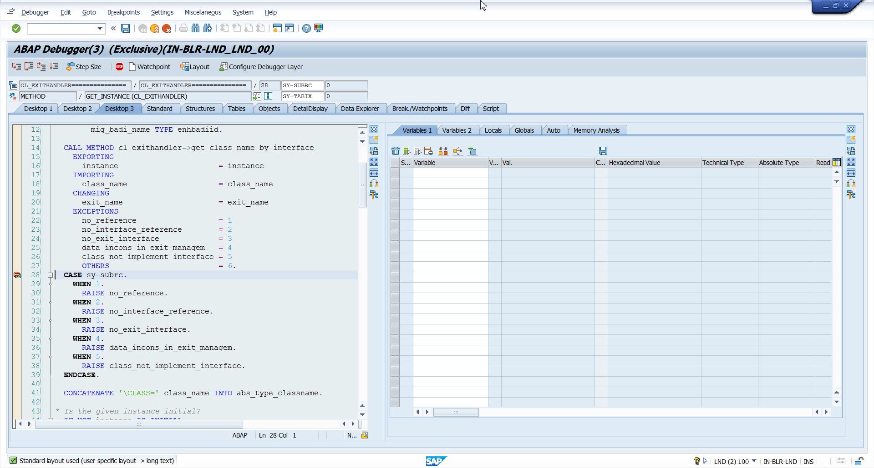

1. Execute the transaction that you want to analyze.  It will stop at the break-point you have just set on class **CL_EXITHANDLER** whenever it finds any BADI method/Exit call.

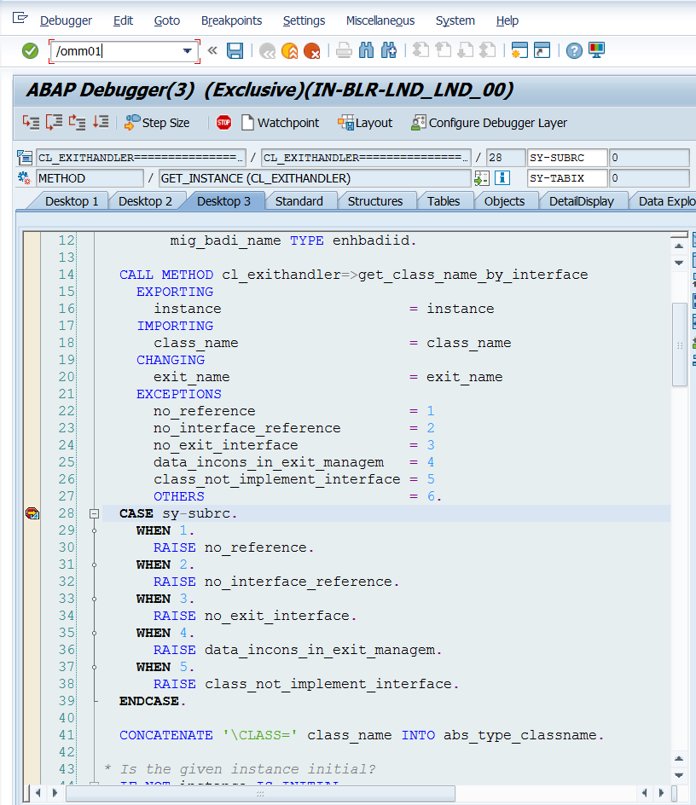

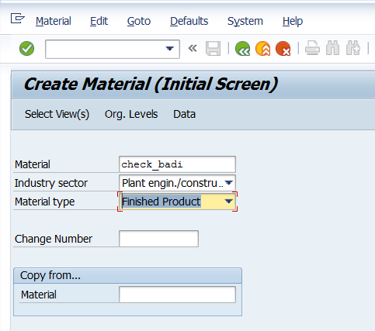

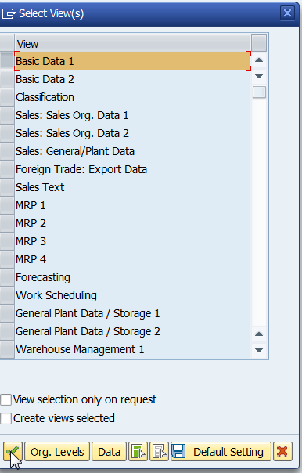

1. d